**Performance Analysis of Social Media Sentiment**

**Analysis Using Machine Learning**

**ABSTRACT**

Social media allows people to spend time together online and interact and connect. The relationship between well-being and social [media usage](https://www.sciencedirect.com/topics/economics-econometrics-and-finance/media-usage) is being studied more and more because it affects many areas and is discussed from different aspects. In this analysis, we explore a synthetic dataset mimicking real-world engagement on platforms like Facebook, Instagram, YouTube and Twitter. Through Exploratory Data Analysis (EDA) and Data visualization to identify the which age group is more addict, what a reason to watch social media etc… we aim to depth analysis of social media. in existing system, to analyse a social media dataset, At the point of time top most influenced social media platform is Facebook. In proposed system, we analyse that which social media platform is peak right now. And comparisons of logistic regression and distilBERT to find the accuracy. Sentiment analysis is an automated way of performing computer analysis of text typed in by a user and the user’s emotion based on the text by using LSTM.

**MATERIAL**

In this social media dataset came from the kaggle to predict social media analysis. The author of this dataset Muhammad Roshan Riaz from cloud Native Generative AI Enthusiast and ML.

**EXISTING SYSTEM**

In Existing system, the project involved to analysis of the social media analysis dataset with proper data processing. Then different model were trained and predictions are made with different models like machine learning algorithms of NLP, Linear Regression, Support vector machine (SVM). Natural Language Processing (NLP): Natural Language Processing understand and interprets human language patterns. Social media platforms such as twitter, Facebook, Instagram uses [NLP](https://www.geeksforgeeks.org/natural-language-processing-nlp-tutorial/)to analyse text data that includes tweets, comments to find sentiment, categorize contents or finding trends. Social media platforms such as Twitter, Facebook analyse their contents of posts to extract patterns and find trends that helps in personalizing advertisement based on user choices. Linear Regression: Linear regression is type of machine learning algorithm that find relationship between the input data and targeted variable. It is a type of statistical model. In social media platform [linear regression](https://www.geeksforgeeks.org/ml-linear-regression/) is used for predicting real values it can be user engagement based on post features. Support Vector Machine:Support Vector Machine are the type of machine learning algorithm that is used for classification task. In social media platform [SVM](https://www.geeksforgeeks.org/support-vector-machine-algorithm/) are used for extracting fraudulent activities. Clustering: Clustering are a type of unsupervised machine learning algorithm. In social media platform [clustering](https://www.geeksforgeeks.org/clustering-in-machine-learning/) are used for recommendation, detecting anomalies.

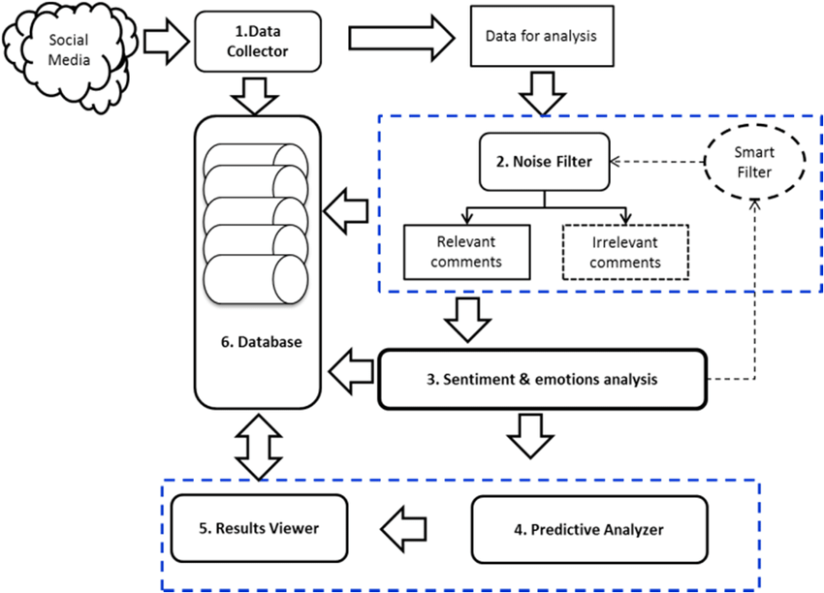

**PROPOSED SYSTEM:**

In proposed system, we analyse that which social media platform is peak right now. And comparison of logistic regression and distilBERT to find the accuracy. To Analyse a Sentiment analysis is an automated way of performing computer analysis of text typed in by a user and the user’s emotion based on the text by using LSTM. To predict a analyse by using Epoch training.

